HEIDENHAIN inductive rotary encoders for robot axes
Intelligent encoders at automatica 2023 are setting new standards in robotics

Robotics and other applications with compact motors stand to benefit from the KCI 1300 (singleturn) and KBI 1300 (multiturn) rotary encoders from HEIDENHAIN. Flat, lightweight and immune to both contamination and magnetic fields, these encoders feature a 25 mm hollow shaft and employ a scanning unit combined with either a screw-fastened circular scale or a press-fit disk/hub assembly. Wide mounting tolerances make installation easy. Mechanical fault exclusion ensures dependable mounting. And the EnDat 2.2 interface provides functionally safe data transmission. Because these encoders support an external temperature sensor, overload protection can be implemented for even greater reliability.

For two variants, HEIDENHAIN wedded the electronics directly to a metal carrier that can act as a bearing cover for the motor. This fan-out technology (FOT) saves space, reduces the number of components and dissipates heat externally through the metal plate. The resulting KCI 1318 FOT and KBI 1335 FOT encoders come with a press-fit disk/hub assembly.

For larger 30 mm and 40 mm hollow shafts, HEIDENHAIN offers the compact KCI 120 and KBI 136 inductive rotary encoders. Designed specifically for robotics applications, these encoders deliver the benefits of the smaller KBI 1300 series to robot axes that are significantly more heavy-duty.

HEIDENHAIN at automatica 2023 in Munich: Hall B6, Booth 303

For more information, visit:
news.heidenhain.com/automation
www.heidenhain.com

Contact person for the trade press:
Ulrich Poestgens
Phone: +49 8669 31-4154
poestgens@heidenhain.de

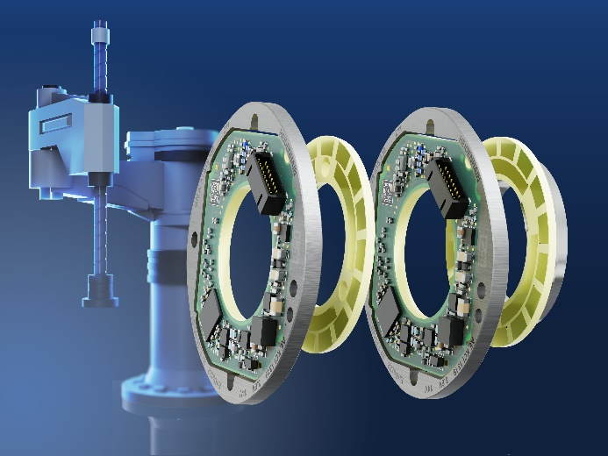 | HEIDENHAIN offers the KCI 1300 and KBI 1300 inductive rotary encoders with a scanning unit combined with either a press-fit disk and hub assembly (on the right) or a screw-fastened circular scale (on the left).
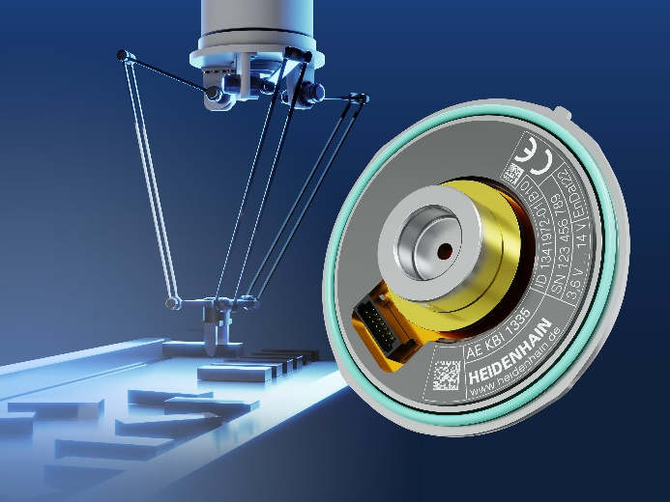 | The FOT variants of the KCI 1300 inductive encoders from HEIDENHAIN can also serve as a bearing cover.
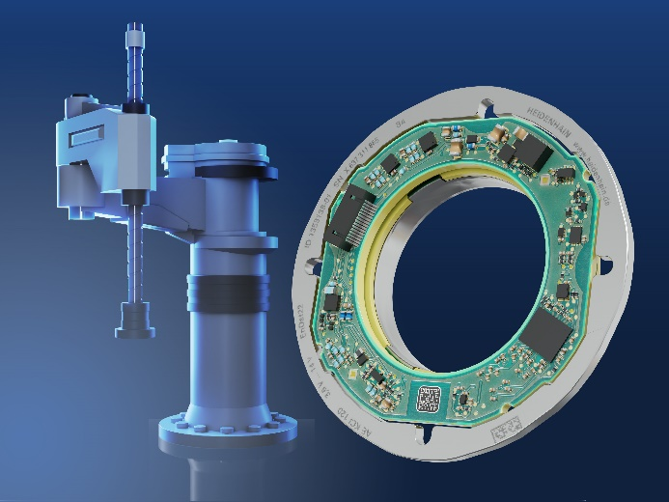 | The KCI 120 and KBI 136 solutions from HEIDENHAIN provide large 30 mm and 40 mm hollow shafts.

